**Acknowledgement**

The main credit for the successful completion of this work belongs to Allah. Gently, we would like to take this opportunity to express our gratitude for everyone who supported, encouraged, and patiently worked with us on this project. To our family, who have done everything within their power to help us succeed at this point in our lives. I also want to express my sincere gratitude to our IT supervisor, who assisted us in choosing our project and generously shared his technical knowledge with us. She provided us with ongoing support throughout the months we worked on the project and provided all the educational resources and supplies we required to advance our academic and professional careers. We also like to express my gratitude and sincere thanks to our business supervisor. Who assisted us and shared a great deal of her business expertise with us, provided us with ongoing support throughout the months of our work, and gave us access to all the business resources we required to meet our project's business objectives. It gives us great pleasure to express our gratitude for the assistance and contributions of Helwan University. We would like to specially thank our supervisor, Dr. Soha Ahmed, and Dr. Thanaa Mohammed for their assistance and contributions that guided us. Finally, We Are Lucky to Work as a Team on This Project. We Understand one another and Work as a Team as One Person, and This Is Our Key Of success. We also want thanks Dr. Gamal Ali for all his efforts within this year at the faculty.

**Many Thanks to all of you.**

# Abstract

**Solarium: *Bridging the Gap for Solar Power in Egypt***

This project charts the course for Solarium, a dynamic startup determined to revolutionize Egypt's energy landscape by scaling the solar panel market. While acknowledging the current utilization of solar power in B2B applications like large-scale farms and water treatment plants, Solarium identifies a critical gap in the B2C sector – the vast potential within residential neighborhoods and commercial buildings.

**Solarium** positions itself as a game-changer, acting as a vital intermediary between established solar panel manufacturers and everyday Egyptians yearning for a sustainable energy solution. This project outlines a strategic roadmap for widespread adoption of solar power across the nation. Our vision is a future where every eligible house and building in Egypt, from bustling commercial centers to cozy family homes, harnesses the clean and abundant power of the sun. By facilitating this transition, Solarium aspires to not only empower individual consumers but also pave the way for a greener, more self-sufficient Egypt, ensuring a brighter and more sustainable future for all.

**CHAPTER ONE: INTRODUTION**

**1.1 Introduction**

***- Illuminating a Brighter Future with Solarium –***

Egypt basks in abundant sunshine, yet its residential and commercial sectors haven't fully embraced the clean energy potential of solar power. This underutilization presents a significant opportunity, and that's where Solarium steps in. We are a pioneering startup dedicated to bridging the gap between established solar panel technology and the vast potential within Egypt's B2C market – homes and commercial buildings.

While the local solar panel industry caters to B2B applications like large-scale solar farms and water treatment plants, countless homes and businesses remain untapped. Solarium aims to change that. We envision a future where every eligible house and building in Egypt harnesses the power of the sun. We see ourselves as the missing link, a facilitator connecting the expertise of solar panel manufacturers with the needs of everyday Egyptians seeking a sustainable energy solution.

However, Solarium goes beyond simply being a middleman. We're committed to offering a comprehensive suite of services to empower Egyptians to embrace solar power. Here's a glimpse into what sets us apart:

Customized Solar Solutions: Gone are the days of one-size-fits-all approaches. Solarium creates tailor-made solar power systems, meticulously designed to meet the unique energy needs and roof space limitations of individual homes and commercial buildings.

Unleashing Affordability with Solar Financing: The upfront cost of solar panels can be a hurdle. Solarium tackles this challenge by offering flexible financing options, including solar leasing or power purchase agreements (PPAs). This makes solar energy a more accessible reality for a wider range of customers.

Harnessing the Power of Community: Not everyone has a suitable roof for solar panels. Solarium facilitates community solar programs, allowing people to invest in or benefit from solar energy without on-site installations.

Building a Greener Future Together: We believe collaboration is key. Solarium fosters Sustainable Partnership Programs by working with local businesses, NGOs, and government entities. This includes educational programs to raise awareness about the benefits of solar power and collaborative efforts to promote widespread adoption.

Unlocking Green Credentials: Solarium recognizes the growing demand for sustainable buildings. We assist buildings in obtaining green certifications (such as LEED) by incorporating solar energy into their design.

By offering these innovative services, Solarium aspires to illuminate a brighter future for Egypt. We envision a greener, more self-sufficient nation powered by clean, renewable energy. Join us on this journey as we bridge the gap and empower Egyptians to embrace the sun's limitless potential.

# 1.2 Project Idea and scope

**1.2.1 Project Idea**

**Solarium** addresses the significant underutilization of solar energy in Egypt. Despite abundant sunshine, the residential and commercial sectors lag in adopting solar power due to the industry's focus on large-scale B2B applications and barriers like high upfront costs and the lack of tailored solutions.

* *Underutilization of Solar Energy in Egypt:* Despite abundant sunshine, Egypt's residential and commercial sectors have not fully leveraged the clean energy potential of solar power.
* *Limited B2C Solar Applications:* The local solar panel industry primarily focuses on B2B applications, such as large-scale solar farms and water treatment plants, leaving homes and businesses largely untapped.
* *Barriers to Solar Adoption:* The introduction hints at challenges such as the high upfront cost of solar panels and the lack of tailored solar solutions for different energy needs and spatial limitations.

So, our idea is providing tailored solar solutions for Egypt’s residential and commercial sectors.

**1.2.1 Project Scope**

The scope of the Solarium project encompasses several key areas aimed at addressing the underutilization of solar energy in Egypt's residential and commercial sectors:

* *Customized Solar Solutions:* Solarium will provide personalized solar solutions tailored to the unique energy needs and spatial limitations of residential homes and commercial buildings. This includes offering a range of products such as rooftop solar panels, solar water heaters, and integrated solar systems.
* *Flexible Financing Options:* To overcome the high upfront costs associated with solar installations, Solarium will offer flexible financing options such as leasing, installment plans, and partnerships with financial institutions. This will make solar energy more accessible to homeowners and businesses, encouraging adoption.
* *Education and Awareness Campaigns:* Solarium will launch extensive education and awareness campaigns to inform the public about the benefits of solar energy. These campaigns will aim to dispel myths and misconceptions surrounding solar power while promoting the importance of sustainable energy practices.

By focusing on these key areas, Solarium aims to drive the widespread adoption of solar energy in Egypt's residential and commercial sectors, contributing to a cleaner, greener, and more sustainable future for the country.

# 1.3 Project objectives

**Solarium** offers innovative solutions to unlock solar energy's potential for Egypt's B2C market. Through customized solar systems, flexible financing, community programs, and partnerships, Solarium aims to make solar power accessible and attractive, fostering a sustainable energy transition.

* Tailor Solar Solutions: Offer custom solar power systems suited to individual needs and spaces.
* Improve Financial Accessibility: Provide flexible financing to make solar energy affordable for more people.
* Increase Solar Adoption & Support Community Solar: Enable participation in solar energy for those without direct installation access.
* Build Partnerships: Collaborate with stakeholders to promote solar energy awareness and adoption.
* Facilitate Green Certification: Help buildings obtain green certifications through solar integration.
* Connect the B2C Market: Bridge the gap between solar panel manufacturers and the residential/commercial markets.

# 1.4 Project features

* Visit project’s site.
* Provide quotation for the design.
* Contract for the Inspection
* Develop the initial 2D design.
* 3D illustrated design.
* Develop 3D design.
* Prepare the project’s final drawings & calculations.
* Prepare bills of quantity and specifications
* Initial handover of the project
* Final touches
* Installation

# 1.5 Related Works

# *(analysis of previous works + determination of the existing problem)*

***Research Papers and Studies on Solar Energy Adoption in Developing Countries:*** Previous studies may have investigated the challenges and opportunities for solar energy adoption in developing countries, including Egypt. These studies may highlight common barriers such as high upfront costs, lack of financing options, and inadequate infrastructure.

(Barriers to Solar PV Adoption in Developing Countries: Multiple Regression and Analytical Hierarchy Process Approach ---- <https://www.mdpi.com/2071-1050/16/3/1032>)

***Case Studies of Successful Solar Energy Projects:*** Analysing case studies of successful solar energy projects in similar contexts can provide insights into effective strategies and best practices. Identifying key factors that contributed to the success of these projects can inform the development of strategies for overcoming barriers to solar adoption in Egypt.

(100 Best Solar Energy Case Studies of 2019--- <https://ecoplaneta.com/solar-energy-case-studies/>)

***Government Initiatives and Policies:*** Reviewing government initiatives and policies related to solar energy adoption can help identify existing efforts to promote solar power in Egypt. However, analyzing their effectiveness and identifying gaps or shortcomings in these policies is crucial for informing recommendations for policy improvements.

(The Role of Government Policies in Promoting the Adoption of Solar Energy ---- <https://arka360.com/ros/government-policies-promoting-solar-energy/> )

***Market Analysis of Solar Industry:*** Conducting a market analysis of the solar industry in Egypt and other relevant regions can provide valuable insights into the current state of the market, key players, trends, and challenges. Identifying existing gaps in the market, such as the lack of tailored solutions for residential and commercial sectors, can help inform the development of Solarium's offerings.

(EGYPT SOLAR PHOTOVOLTAIC MARKET SIZE & SHARE ANALYSIS - GROWTH TRENDS & FORECASTS (2024 - 2029) ---- <https://www.mordorintelligence.com/industry-reports/egypt-solar-photovoltaic-market> )

By conducting a thorough analysis of these related works, Solarium can gain valuable insights into the existing problems and challenges facing solar energy adoption in Egypt. This analysis will inform the development of targeted strategies and solutions to overcome these barriers and promote the widespread adoption of solar power in the country.

# 1.6 Project requirements

Project requirements are the features, functions, and tasks that need to be completed for a project to be deemed successful System requirements are the configuration that a system must have for software and hardware application to run it in efficient way and to meet the requirements for our project and failure to meet these requirements will lead to installation problem and performance problem. There are software requirements and hardware requirements.

**Tools and language**

As for web development, using different programming languages is an essential part of our project.

* **HTML** (Hypertext Markup Language), for example is a markup language used to create web pages. It is the standard language used to create websites and web applications. HTML is used to structure content on a web page, such as text, images, and multimedia, and to define how the content should be displayed in a web browser. HTML uses tags to define elements and attributes to specify additional information about elements. When a web page is loaded in a browser, the HTML code is interpreted and rendered as a visual representation of the content.
* **CSS** (Cascading Style Sheets) is a style sheet language used to describe the visual appearance and layout of a web page. It is used in conjunction with HTML and JavaScript to create visually appealing and functional websites and web app
* **JavaScript** is a dynamic programming language central to developing interactive and responsive web applications. It runs in web browsers, allowing for client-side script execution to create interactive user interfaces without reloading the page. With the advent of Node.js, JavaScript has also become popular for server-side development, enabling full-stack development with a single language. It supports various programming paradigms, including object-oriented and functional programming. JavaScript's extensive ecosystem includes numerous libraries and frameworks, such as React, Angular, and Vue.js, facilitating efficient and sophisticated web application development.
* **PHP** (Hypertext Preprocessor) is a server-side scripting language used for web development. It is a popular and widely used language that is designed to create dynamic web pages and web applications. While it can be challenging to keep up with the latest trends and tools, using different programming languages is an exciting and rewarding process. Each language brings its own unique set of features and benefits that can help create a dynamic and engaging website for clients and users. For the project, I am utilizing MySQL and PhpMyAdmin along with XAMPP to create a robust and efficient web application:
* **MySQL** provides a reliable and scalable database management system that can handle large amounts of data.
* **PhpMyAdmin** complements MySQL by providing a user-friendly interface to manage the database. It allows us to create tables, add data, and run SQL queries easily.
* **XAMPP** simplifies the process of setting up a local development environment by bundling together Apache, MySQL, PHP, and other tools that are essential for web development. By using these tools in combination, I can develop, test, and deploy our web application quickly and efficiently. This setup also allows me to easily make changes and updates to the database and test them before pushing the changes live.
* **Visual Studio Code** is a popular open-source code editor that is used by developers worldwide. It was developed by Microsoft and is available on Windows, macOS, and Linux. Visual Studio Code is designed to be lightweight, fast, and customizable, making it suitable for a wide range of programming languages and frameworks.
* **Microsoft Project** is a project management software developed and sold by Microsoft. It is designed to help project managers and teams plan, track, and manage projects of various sizes and complexities.9

**Microsoft Project provides a range of features and tools to help with project planning and management. These include:**

***1. Gantt charts*** – Microsoft Project allows users to create Gantt charts that provide

a visual representation of the project timeline, tasks, and dependencies. This allows users to easily track progress and identify potential issues.

***2. Resource management*** – Users can assign resources, such as team members or equipment, to specific tasks and track their availability and usage throughout the project.

***3. Task scheduling*** – Microsoft Project allows users to define task durations, dependencies, and constraints to create an optimized project schedule.

***4. Budget tracking*** – Users can track project costs and budget using built-in budgeting tools.

# 1.7 System users

* System admin.
* Clients.
* Design Engineer

**1.8 System methodology**

We used a methodology Called **Waterfall Methodology**

The Waterfall methodology — *also known as the Waterfall model* — is a sequential development process that flows-like a waterfall through all phases of a project (analysis, design, development, and testing) with each phase completely wrapping up before the next phase begins.

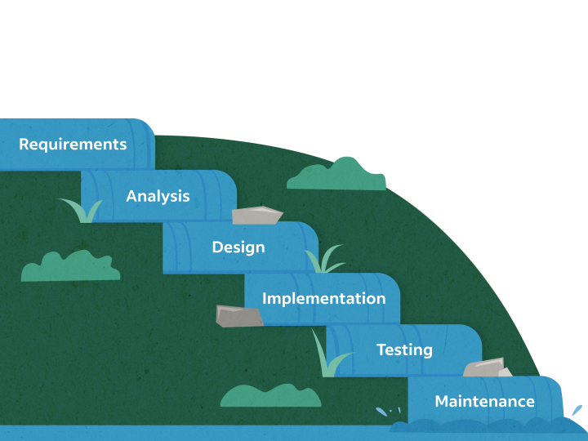

Figure 3.1 (waterfall methodology)

**1.8.1 Requirements**

The Waterfall methodology depends on the belief that all project requirements can be gathered and understood upfront. The project manager does their best to get a detailed understanding of the project sponsor’s requirements. Written requirements, usually contained in a single document, are used to describe each stage of the project, including the costs, assumptions, risks, dependencies, success metrics, and timelines for completion.

**1.8.2 Design**

Here, software developers design a technical solution to the problems set out by the service requirements, including scenarios, layouts, and data models. First, a higher level or logical design is created that describes the purpose and scope of the project, the general traffic flow of each component, and the integration points. Once this is complete, it is transformed into a physical design using specific hardware and software technologies. (Frontend).

**1.8.3 Implementation**

Once the design is complete, technical implementation starts. This might be the shortest phase of the Waterfall process because painstaking research and design have already been done. In this phase, programmers code applications based on project requirements and specifications, with some testing and implementation taking place as well. If significant changes are required during this stage, this may mean going back to the design phase. (Backend).

**1.8.4 Verification or testing**

Before a service can be released to customers, testing needs to be done to ensure the service has no errors and all the requirements have been completed, ensuring a good user experience with the software. The testing team will turn to the design documents, personas, and user case scenarios supplied by the service manager to create their test cases.

**1.8.5 Deployment and maintenance**

Once the software has been deployed in the market or released to customers, the maintenance phase begins. As defects are found and change requests come in from users, a team will be assigned to take care of updates and release new versions of the software.

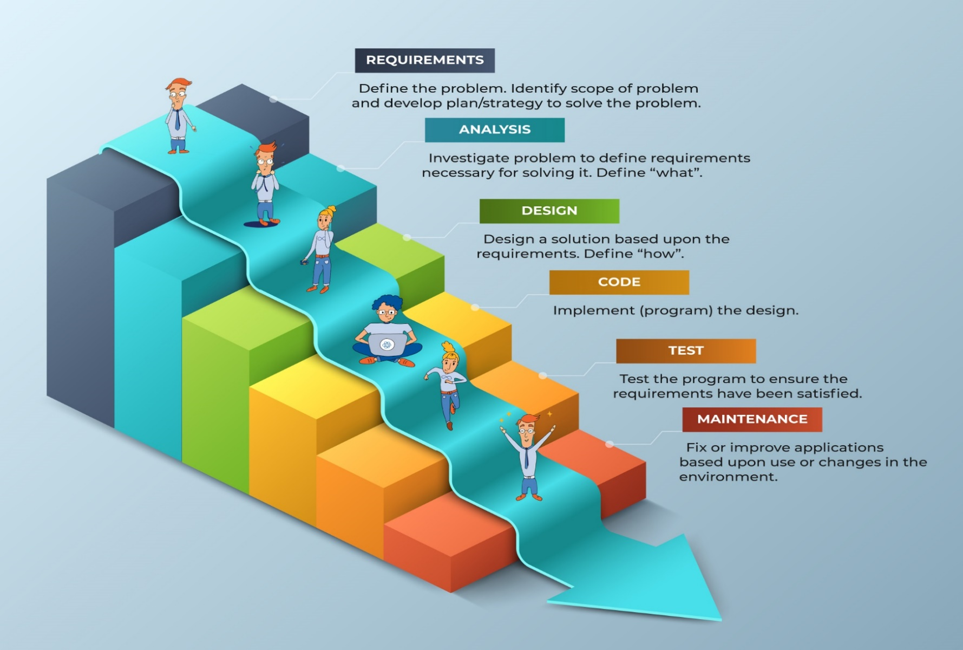

Figure 1.2 (waterfall methodology steps)

**1.9 Project Time Plan**

**Gantt chart**

A Gantt chart is a project management tool that helps in planning, scheduling and monitoring a project.

A Gantt chart represents all information visually through a horizontal bar graph. In our project, the Gantt chart describes specifically the phases of development, either simultaneous or sequential. Starting from making the business plan with all of its steps, moving on to the system analysis and design phase where all the diagrams are made, system implementation where the work begins logically on the website, either back end, or front-end development, then finally the system testing phase where the project is tested and made sure that everything is working perfectly.

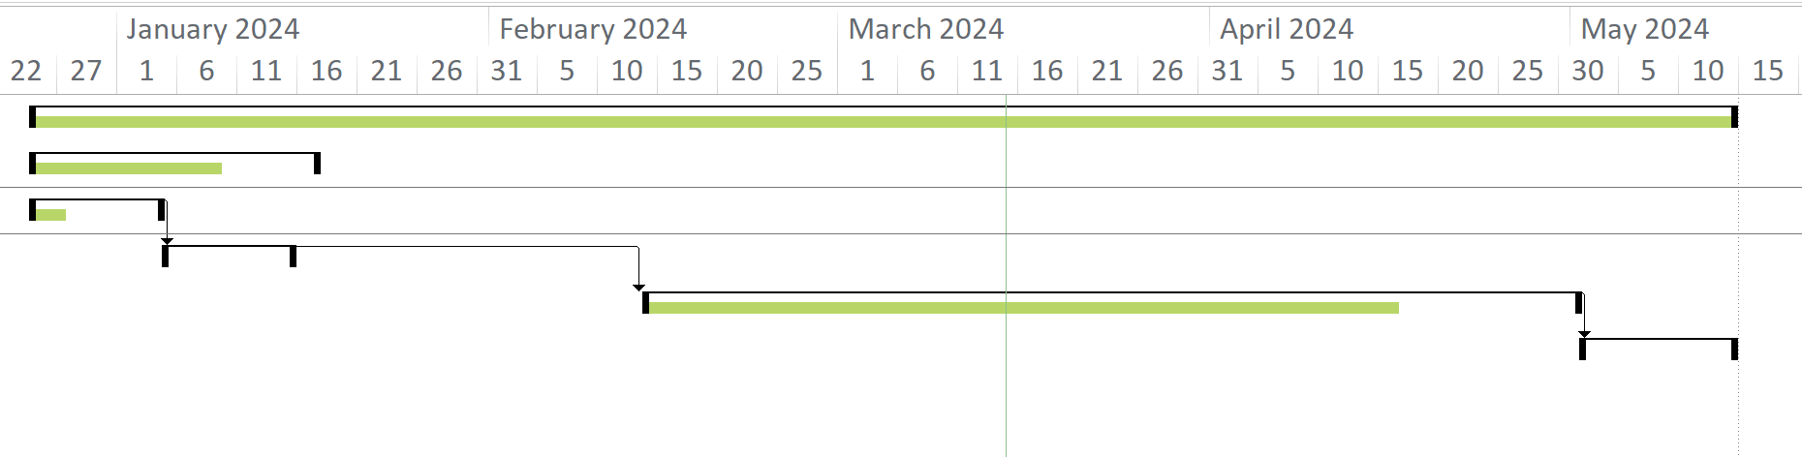

Gantt chart

Figure 1.1

الباقي عايز يتعدل لسه جزء ال FS SS SF FF**CHAPTER TWO: BUSINESS PLAN**

**2.1 Executive Summary**

**CHAPTER THREE: SYSTEM ANALYSIS**

**3.1 Introduction**   
During the analysis phase, the analyst determines the functional requirements for the new system. This chapter begins by describing the analysis phase and its primary deliverable, the system proposal.   
The analysis phase is so named because the term analysis refers to breaking a whole into its parts with the intent of understanding the parts’ nature, function, and interrelationships. In the analysis phase, the systems analyst works extensively with the business users of the new system to understand their needs from the new system.

**3.2 User Requirements**

**3.2.1 Functional Requirements**

*What are Functional Requirements?*

“Any Requirement Which Specifies What the System Should Do.” In other words, a functional requirement will describe a particular behavior of function of the system when certain conditions are met.

Functional requirements are product features or functions that developers must implement to enable users to accomplish their tasks. So, it’s important to make them clear both for the development team and the stakeholders. Generally, functional requirements describe system behavior under specific conditions. For example: The system sends an approval request after the user enters personal information. A search feature allows a user to hunt among various invoices if they want to credit an issued request. The system sends a confirmation email when a new user account is created. The system allows clients to request an inspection for his unit and see design`s on our web application.

**3.2.1.1 Clients**

* ***Register***

The user must enter a basic information about himself and his organization.

* ***Login***

*The user must enter his email and password to access the system.*

* ***Request inspection.***
* ***Contact Customer support.***
* ***Manage account.***
* ***View order history.***
* ***Feedback.***

**3.2.1.2 Engineers**

* *Login*
* *Manage product listing.*
* *Request inspection.*
* *Analyze user’s feedback.*
* *Monitor website performance.*
* *Resolve technical issues.*
* *Generate reports.*

**3.2.1.3 Technicians**

* *Login*
* *Monitor website health.*
* *Perform regular maintenance.*
* *Provide technical support.*

**3.2.1.4 Admin**

* *login*
* *Check requests.*
* *Manage users accounts.*
* *Monitor website activity.*
* *Coordinate with business partners.*

**3.2.2 Non-functional requirements**

What are non-functional requirements?   
“Any Requirement That Specifies How the System Performs a Certain Function.” In other words, a non-functional requirement will describe how a system should behave and what limits there are on its functionality. Non-functional requirements cover all the remaining requirements which are not covered by the functional requirements. They specify criteria that judge the operation of a system, rather than specific behaviors.

* **Performance**: content loading is a priority as users spend more time viewing content than uploading content.
* **Usability**: users should be able to intuitively navigate between profiles and their subscriptions.
* **Reliability and scalability**: the system should work well in low latency conditions, showing media content with the smallest delay possible.
* **Profitability**: the degree to which a business or activity yields profit or financial gain
* **Wide Variety:** is a merchandising strategy that relies on an impressive range of goods to draw customers into the store.
* **Compatibility**: a state in which two things can exist or occur together without problems or conflict
* **Capacity**: the maximum amount that something can contain
* **Localization**: the fact of being or becoming located or fixed in a particular place.
* **Data integrity:** is a term to understand the health and maintenance of any digital information. For many, the term is related to database management. For databases, there are four types of data integrity. Entity Integrity: In a database, there are columns, rows, and tables.
* **Security:**  is the practice of protecting digital information from unauthorized access, corruption, or theft throughout its entire lifecycle.

**3.3 System Requirements.**

**4.1 Software Requirements:**

***Updated version of browser***

* Google Chrome (42-112)
* Microsoft Edge (14-109)
* Safari (10.1-16.3)
* Firefox (39-111)

***Operating system***

* Windows (8-11)
* MAC OS (11-13)
* Android (10-14)
* IOS (10-14)

**4.2 Hardware requirements:**

* Desktop computer (core i5-i7,6gb ram, VGA card, 32-64bit)
* Smart phones
* Internet connection (ADSL at least 1MB)

**3.4 System Diagrams**

**3.4.1 Use case diagram**.

Diagram is a graphical depiction of a user's possible interactions with a system, and it is a behavioral diagram. A use case diagram shows various use cases and different types of users the system has and will often be accompanied by other types of diagrams as well. The use cases are represented by either circles or ellipses. The actors are often shown as stick figures have only 4 major elements: The actors that the system you are describing interacts with, the system itself, the use cases, or services, that the system knows how to perform, and the lines that represent relationships between these elements.

**Use Case 1: Client use case diagram.**

Client as an actor if it is new client it will go to sign up page he/she will enter name, email, phone, password, confirm password and the address then it will redirect to sign in page and if the user is already exists it will redirect to sign in page by entering the email and password and if the client wrote the password wrong or forgot password by tap on it and write new password it will redirect to service page and if he/she wants to request there is 3 services (roof assessment , energy consumption analysis , financial evaluation) and there is 2 options (apartment, house) you can choose between them and client can make feedback by write his/her feedback and client can also logout.

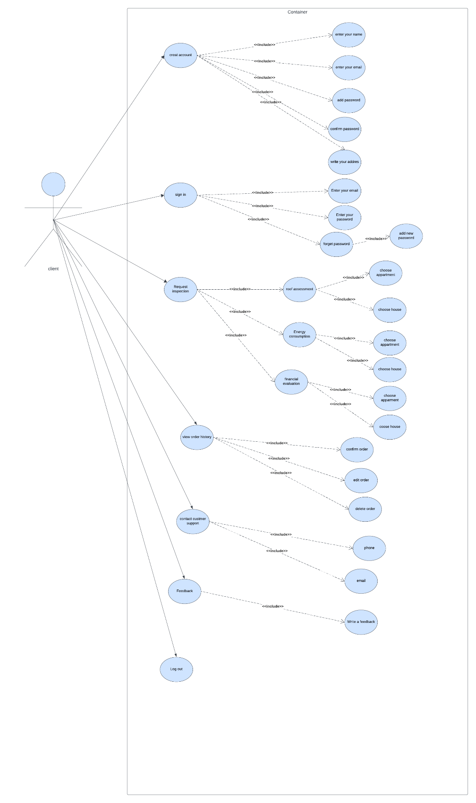

Figure 1.1 (use case(client))

**Use case 2: admin use case diagram.**

figure1.2(Use case(admin))

**Use case 3: Engineer use case diagram.**

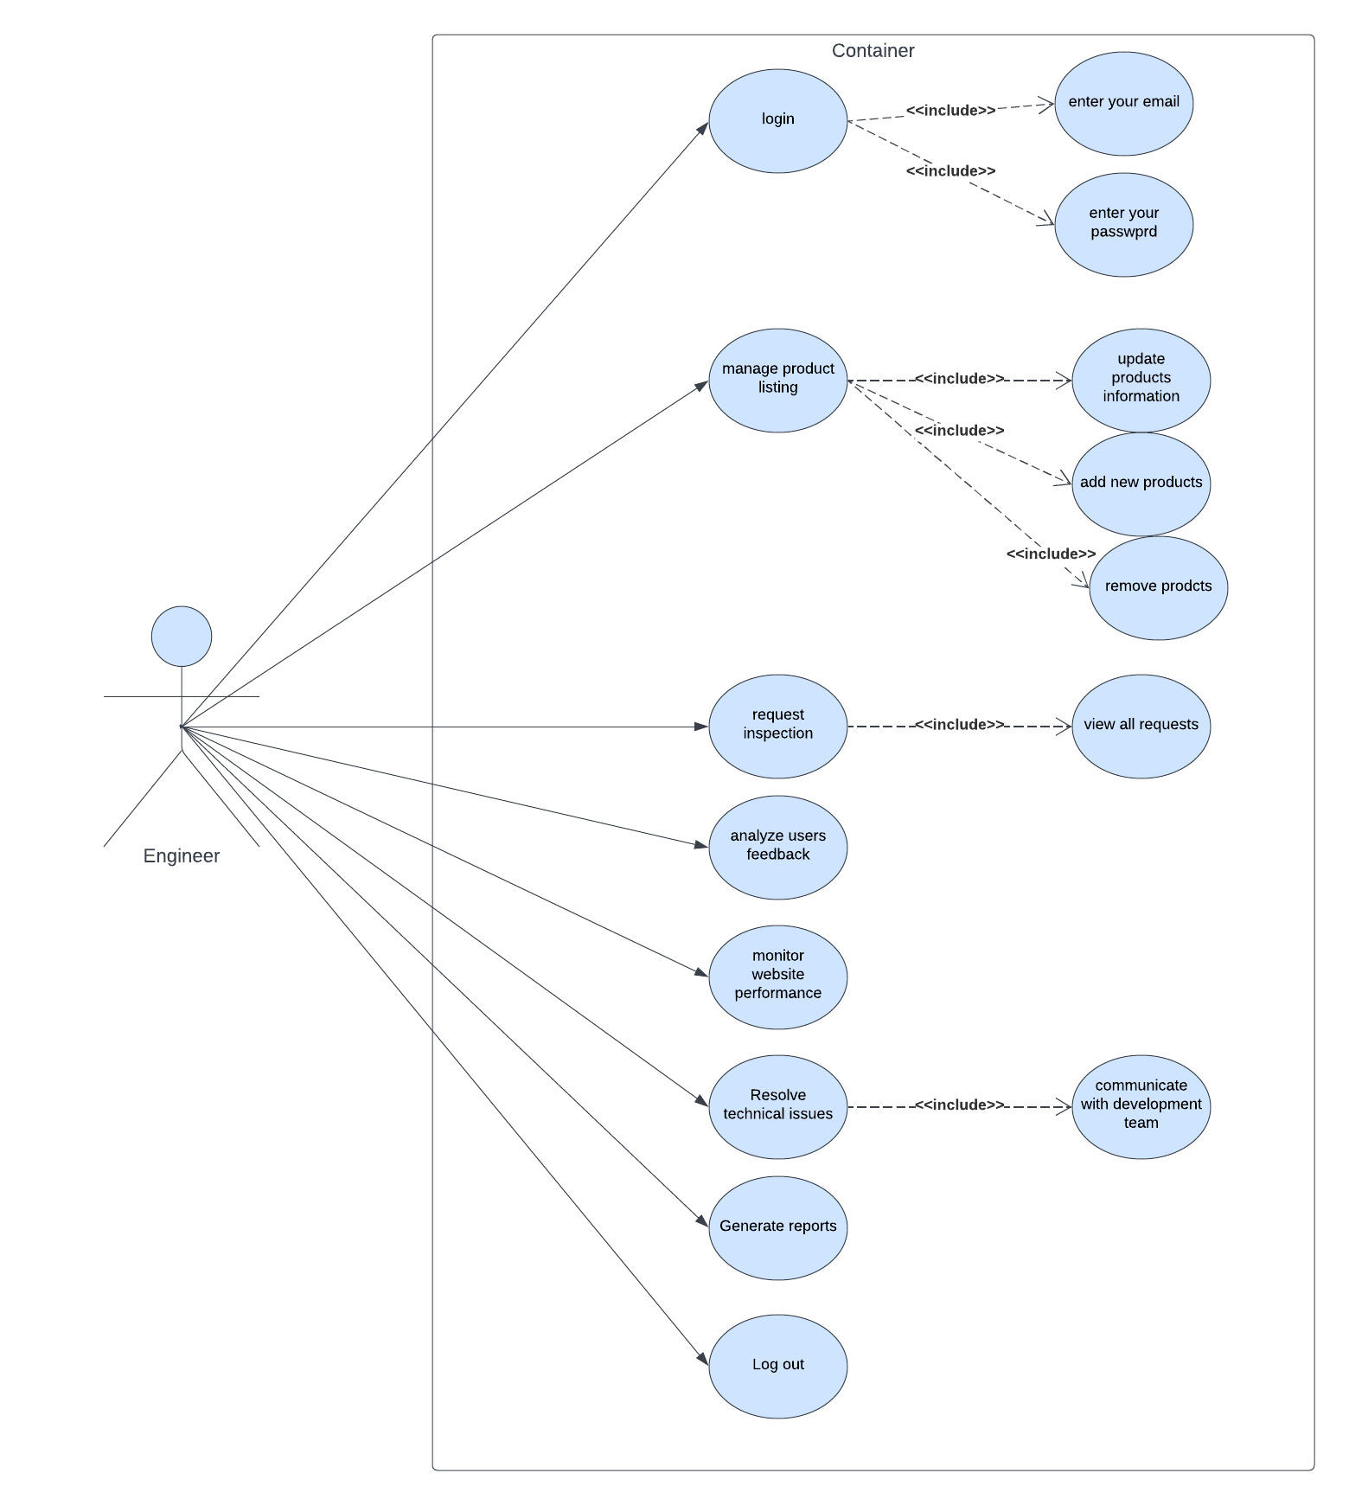

figure1.3(Use case(engineer))

**Use case 4: technician use case diagram.**

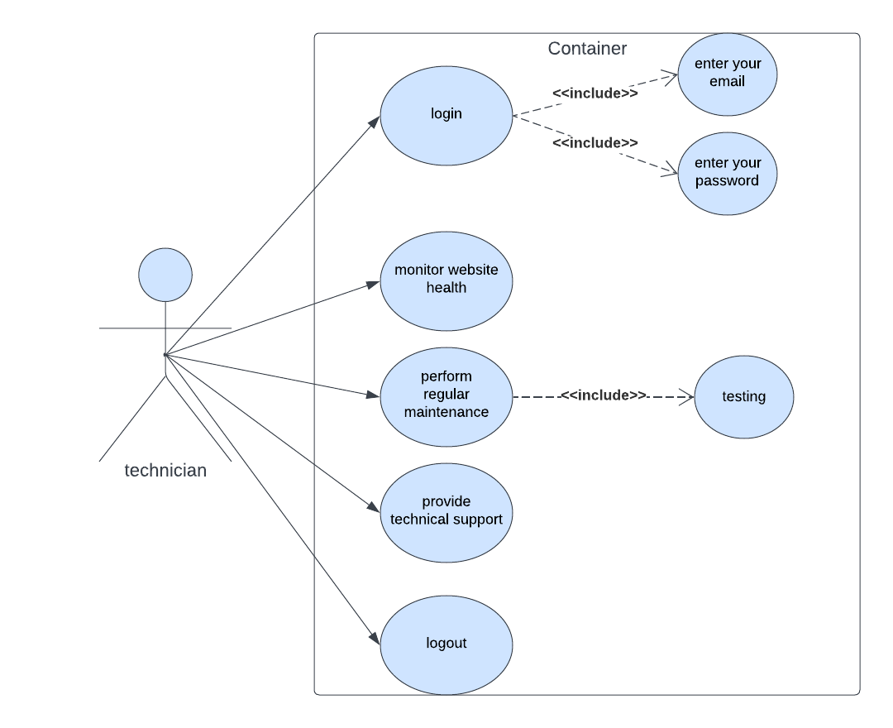

figure 1.4(use case (technician))

**3.4.2 Sequence diagram**

What is Sequence diagram? A sequence diagram is a Unified Modeling Language (UML) diagram that illustrates the sequence of messages between objects in an interaction. A sequence diagram consists of a group of objects that are represented by lifelines, and the messages that they exchange over time during the interaction. A sequence diagram shows the sequence of messages passed between objects. Sequence diagrams can also show the control structures between objects. The sequence diagram shows the objects and the messages between the objects.

**Sequence diagram** **1: client registration**

In figure 2.1: Client registration, it will show if the client is new to our system It will require to create a new form it will need him/her to enter username, password, email, address and phone then it will validate the form and send the information to database to check it will check if he is new it will be register successfully but if he already in the system old user it will shows user already exists in the system.

Figure 2.1(sequence diagram(register))

**Sequence diagram 2: Login Sequence**

Figure 2.2: Login sequence in the login form It will need the client to enter his email and password then it will send email and password to the database it will validate user data if user login accepted it will redirect to our service page and if email and password is not found as user login is rejected it will show up rejected.

Figure 2.2(sequence diagram(login))

**Sequence diagram 3: request Sequence**

Figure2.3 in the request page client chose request type and request name and it validate the   
request information and send it for database, database save client request and if the request   
accepted it will show accepted message and if the request failed or rejected it will show rejected message.

Figure 2.3(sequence diagram(request))

**Sequence diagram 4: Feedback sequence**

Figure 2.4 in golden: feedback the client could write his feedback then it will send client feedback to database to save it then feedback will save successfully, and it appear in homepage to the clients.

figure 2.5 (Sequence diagram(feedback))

**Sequence diagram 5: Logout sequence.**

Figure 2.5 In the logout page User (client, admin, designer) will request to logout, it send request to database then it confirmed it and redirect user to home page.

Figure2.5(Sequence diagram(logout))

**3.4.3 Activity diagram**

Activity diagrams are graphical representations of workflows of stepwise activities and actions with support for choice, iteration and concurrency. In the Unified Modeling Language, activity diagrams are intended to model both computational and organizational processes (i.e., workflows), as well as the data flows intersecting with the related activities. Although activity diagrams primarily show the overall flow of control, they can also include elements showing the flow of data between activities through one or more data stores. Activity diagrams are constructed from a limited number of shapes, connected with arrows.

**Activity diagram 1: Sign up.**

in our activity diagram in register (figure 3.1) in the first we will start up by the start node and after that action we will fill the personal data of the client then it will create an account and validate the form and check if user exists, he will be redirected to sign in page, then write the email and password then the service page and then the end node.

Figure 3.1(Activity diagram (register)

**Activity diagram 2: Sign in.**

in our activity diagram in sign in (figure 3.2) page the client will go to and fill his email and password and check and validate data if it is not valid it will go back to the page and if it is valid, will go to the request service page then end node.

Figure 3.2 (Activity diagram (sign in))

**Activity diagram 3: Request**

in our activity diagram in the request (figure 3.3), we would check the request statues if he ordered once or not if client requested once he will go back to the service page and if is not it will be request successful and he can choose what service he want from our 3 services and 3 options.

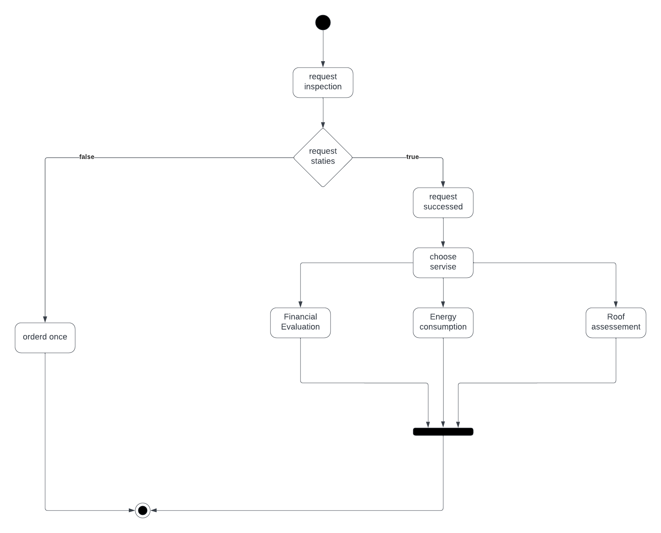

figure 3.3(activity diagram(request))

**Activity diagram 3: Feedback**

Our activity diagram of feedback (figure 3.4) the client will sign in then client go to request services then if he has feedback, he can write it if he is not, he will be redirected to request service page.

Figure 3.4 (Activity diagram (feedback))